**Updatable Website**

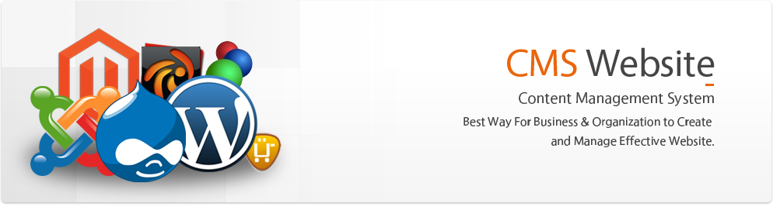**What is CMS?**

A Content Management System (CMS) is a set of tools that lets you create and maintain your website’s content without knowing anything about programming, design, or HTML.

To use a Content Management System you don’t have to be a technical person or have any prior experience in web designing! Now imagine you will be able to achieve the following all by yourself or by somebody who is responsible for the website within your organization through a very easy to use browser based dashboard.

**1. Create new categories or sections within your website**

**2. Add content (text, pictures, documents, videos)**

**3. Delete content**

**4. Modify content**

**5. Retrieve content**

Multiple users can contribute to content management by being given rights and permissions. For example, a user can be limited to just managing news on an ‘Updates’ page.

Content Management is simply the best way for businesses and organizations to create and manage effective websites.

**CMS Solutions:**

We at Quick Web designs develop customized website content management systems and we also integrate some of the most popular ones available today.

We also offer CMS Systems Maintenance Services to keep your web presence current and comprehensive in case you feel your scope of work is more customized.